1. After simulating or otherwise verifying your design, create or import a constraints file to the constraints folder in the Sources pane of the Project Manager window.
- Use the ZYNQ7000 FPGA Development Board AX7010 – User Manual to determine the pin assignment.
- PL = Programming Logic accessible to FPGA fabric and ARM
- PS = Processing System only accessible to ARM

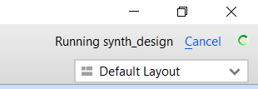
2. Click Generate Bitstream in the Project Manager window
- In the Launch Runs pop-up, click OK
- The upper right corner of the Vivado window will show progress

3. Connect the USB cable and power cable to the ALINX board.
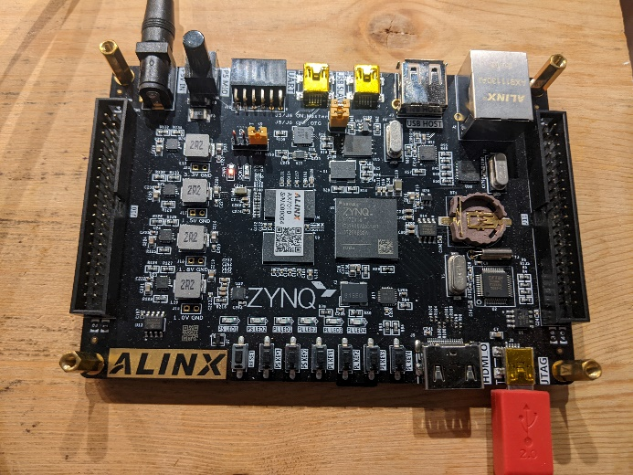

3. Opening the implemented design is a waste of time, just close this window.
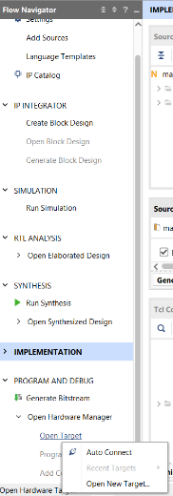
4. Click on Open Target -> Auto Connect.

5. At the top of the screen in a green bar, click Program device
- Click Program in the Program device pop-up

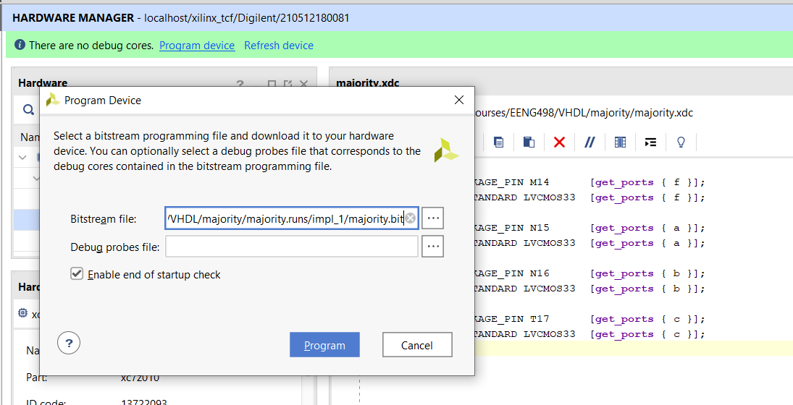

6. Your design is successfully programmed.

